**Assignment 2.7**

**HIVE**

1. **Create a database named 'custom'.**

**Create database custom;**

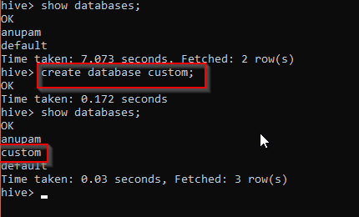

1. **Create a table named temperature_data inside custom having below fields:**
   1. **date (mm-dd-yyyy) format**
   2. **zip code**
   3. **temperature**

**The table will be loaded from comma-delimited file.**

**Load the dataset.txt (which is ',' delimited) in the table.**

Using custom database for this activity;



Creating temporary table



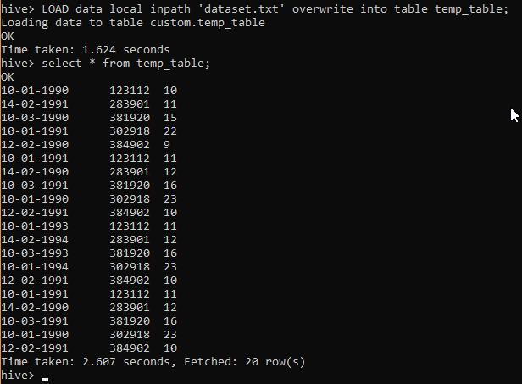

Creating the actual table



Inserting data after converting to correct date format



